|  |  |  |  |  |  |
| --- | --- | --- | --- | --- | --- |
| LEARNING PROFILE FOR RandomMosaicWalk | | | | | |
| *Name* | *:* | *Tyler Lucas* | *Submission Date* | *:* | *N/A* |
| *Student ID* | *:* | *3305203* | *Date Created* | *:* | *2017-05-19* |

# Problem Statement

Textbook example program.

# Description of the Code

This program opens a window full of randomly coloured squares. A “disturbance” moves randomly around in the window, randomly changing the colour of each square that it visits. The program runs until the user closes the window.

# Errors and Warnings

No errors.

# Sample Input and Output

## [Version 1.0]

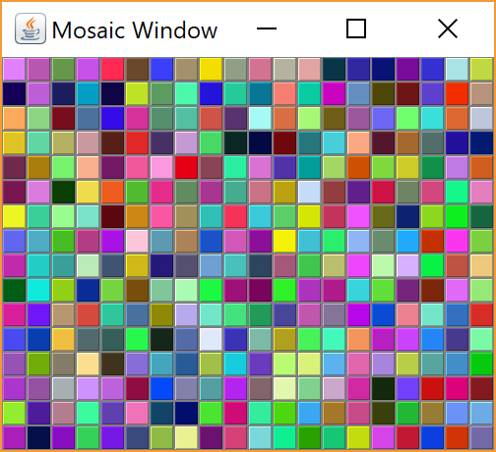

## [Version 1.1]

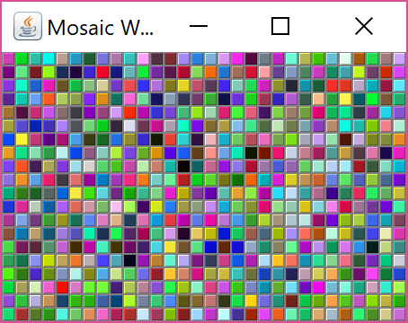

# Discussion

No errors.

Neato. Not going to spend time on this, as this GUI stuff is outdated.